Lesson 02 – LINQ 2

**Using Task List**

1. Open **Task List** window from the menu **VIEW**, **Task List**.

Use the **Filter** function in the Project heading to display only the Task for Lesson02 (top left drop down).

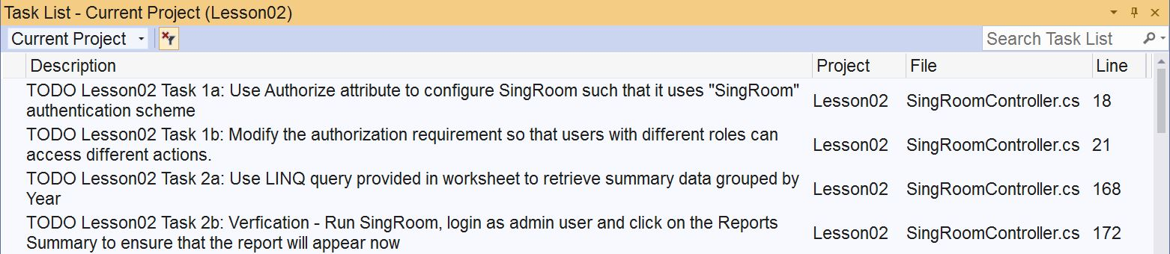

1. **Activity 1:** Perform Task 1a to Task 1e to add in the role-base security to SingRoom web app. Certain tasks are inside **_SingRoomLayout.cshtml**.
2. To test your task, refer to **SRUser** table for available user accounts. By default, [carl@yahoo.com](mailto:carl@yahoo.com) is the only admin user for SingRoom. The password is **password.**
3. Examine in details the LINQ query provided in **Views\LINQ\Demo.cshtml**. Your lecturer will demonstrate this view with some explanations. Please pay attention to it.
4. **Activity 2:** Perform Task 2 to complete the Sales Summary Report. You need to open **SalesSummary.cshtml** to see tasks 2g and 2h. LINQ queries for task 2a and 2c are provided below:

Task 2a LINQ query

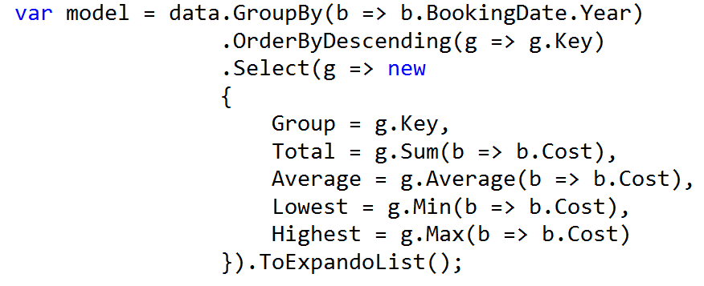

Task 2c LINQ query

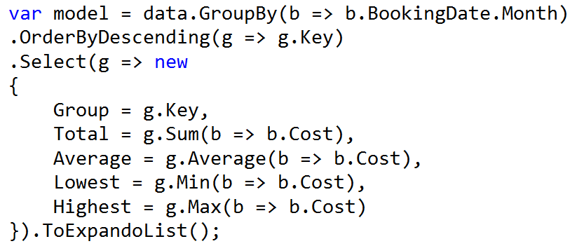

1. Use the following screenshots to verify your result for activity 2 :
   * + 1. Overall sales summary grouped by year

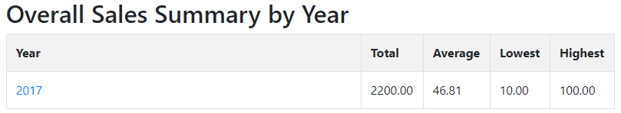

* + - 1. Sales summary for a given year grouped by month

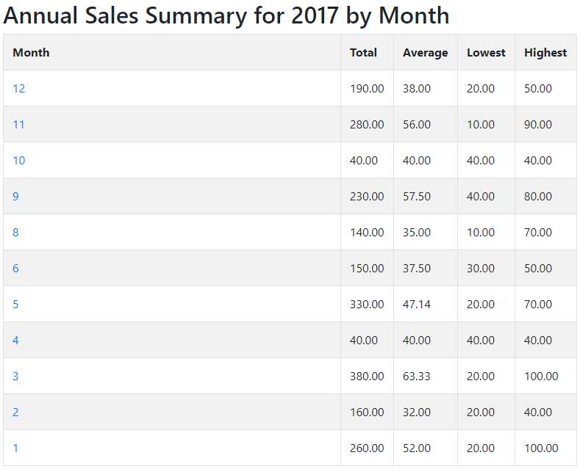

* + - 1. Sales summary for a given month grouped by day

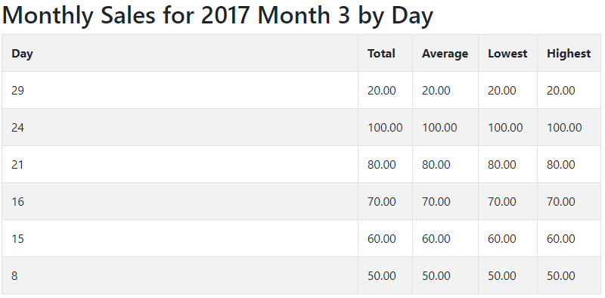

# Solving the Problem

1. You are suggested to complete the solution in the following order:
   * + 1. Role-based Security
          1. Refer to **Task 1** on how to implement this feature
          2. You need to create a another account controller for the Pet Hotel web app
          3. You can use “PetHotel” as the authentication scheme
       2. Sales Summary
          1. Refer to **Task 2** on how to implement this feature
       3. Reports
          1. Refer to **LINQ Demo** and **Task 2** on how to implement this feature
       4. Update and Delete functionalities

# Testing Your Solution

1. Find out who are the users of this web app by examining the file **DBSetup.txt**. Which table should you look at?

-PHUser

1. Complete the following table for three users of the web app.

|  |  |  |  |
| --- | --- | --- | --- |
| **Email** | **Name** | **Password** | **Role** |
| [bernard@yahoo.com](mailto:bernard@yahoo.com) | Bernard | password | Admin |
| [ina@yahoo.com](mailto:ina@yahoo.com) | Ina | password | User |
| [jaime@yahoo.com](mailto:jaime@yahoo.com) | Jaime | password | User |

1. Test Cases:
   * + 1. Login as the admin user and other normal users to ensure all admin resources are secure.

* + - 1. Sales Summary and Reports output match the screenshots in appendix.

* + - 1. Update and delete functionalies are working well.

Provide necessary screenshots here to prove you have successfully tested your web app.

*— End of Worksheet —*